**Project:**

**Library Management System**

**Use Case: Login**

**Name: Sohail Gran**

**Rollno: SP23-BSE-039**

**Use Case Diagram:**

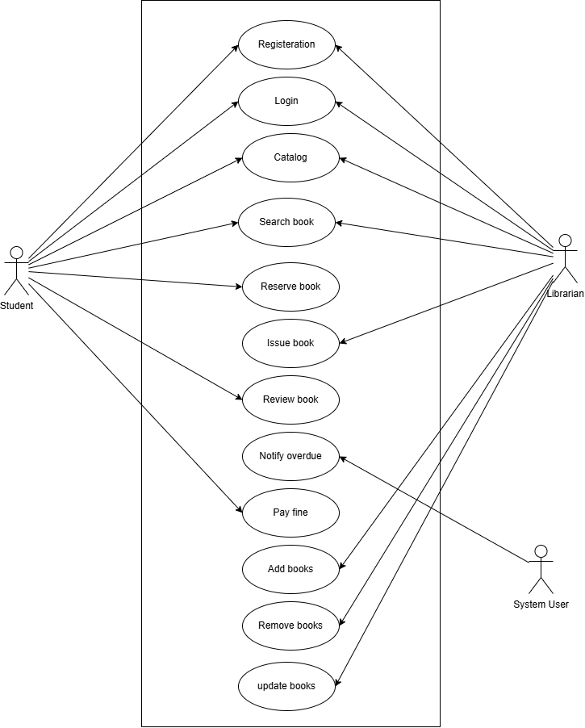

**Fully Dress Use Case:**

**Login Use Case:**

|  |  |
| --- | --- |
| **Use Case ID:** | **UC-2** |
| **Use Case Name:** | **Log In** |
| **Actors:** | **User/student** |
| **Description:** | **This use case describes the process by which a student logs in to the system to access their account** |
| **Trigger:** | **The guest intends to access their account in the Library management system.** |
| **Preconditions:** | 1. **The user must have a registered account in the system.** 2. **The guest must have valid credentials (username and password) to log in.** |
| **Postconditions:** | 1. **If successful, the student is logged in to their account and gains access to the system** 2. **If unsuccessful, the student is not logged in, and appropriate error messages are displayed.** |
| **Normal Flow:** | 1. **The student navigates to the login page of the system.** 2. **The system presents the login form, prompting the student to enter their username and password.** 3. **The guest submits the login form.** 4. **The system verifies the entered credentials against the stored user data.** |
| **Alternative Flows:** | **If the system detects that the entered credentials are invalid during step**  **a. The system displays an error message indicating that the login attempt failed due to incorrect credentials.**  **b. The guest is prompted to re-enter their credentials.** |
| **Exceptions:** | **if the system is down or inaccessible during any step of the process, the system displays an error message informing the student of the issue and advises them to try again later.** |
| **Business Rules** | 1. **Student must provide valid credentials (username and password) to log in.** 2. **The system should enforce security measures, such as encryption of passwords, to safeguard user data.** |
| **Assumptions:** | 1. **The student has a stable internet connection to access the hotel reservation system.** 2. **The student account information is securely stored in the system's database.** |

**SSD for Login**

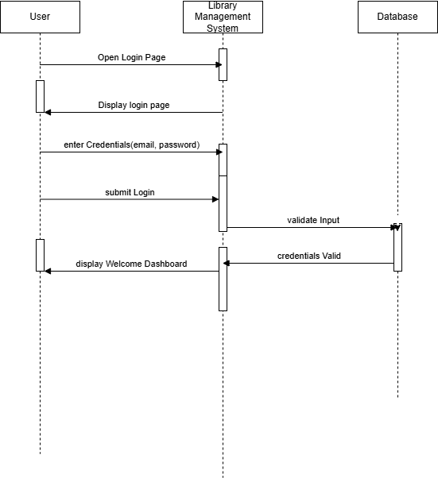

**Class Diagram:**

**Operational Contract:**

**For Login:**

|  |  |
| --- | --- |
| **ID** | **2** |
| **Name** | **User login** |
| **Cross Reference** | **Use Case – User Login** |
| **Pre Condition** | **The user must be registered in the system.** |
| **Post Condition** | * **Credentials are validated.** * **A session is started if the login is successful.** * **Error message is shown if credentials are invalid.** |
| **Object Involved** | * **User** * **Login Form** * **Authenticator** |